

Dr. Gregg, Ford inc.

2024-07-28

Dr. Ford

PSC 7906, Box 4841, APO AA 97091

Phone: 3457429814

Fax: 614871548

**Re:** Melissa, Taylor

**PHN:** 3201620250

**Birthdate:** 04-Apr-1978

**Address:** 666 Walters Park Apt. 337, Hannahside, PA 89428

**Patient number:** 1058026287

To Whom It May Concern:

This is a medical letter to state the above patient is pregnant with expected delivery date of 29-Mar-2025. Hoping this information is satisfactory for your requirements.

Thank you.

Sincerely,

Dr. Gregg, Ford

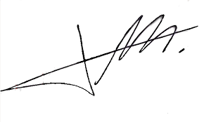

FRCS© NCMP

Clinical Assistant Professor, UBC

Department of Obstetrics and Gynecology SMH